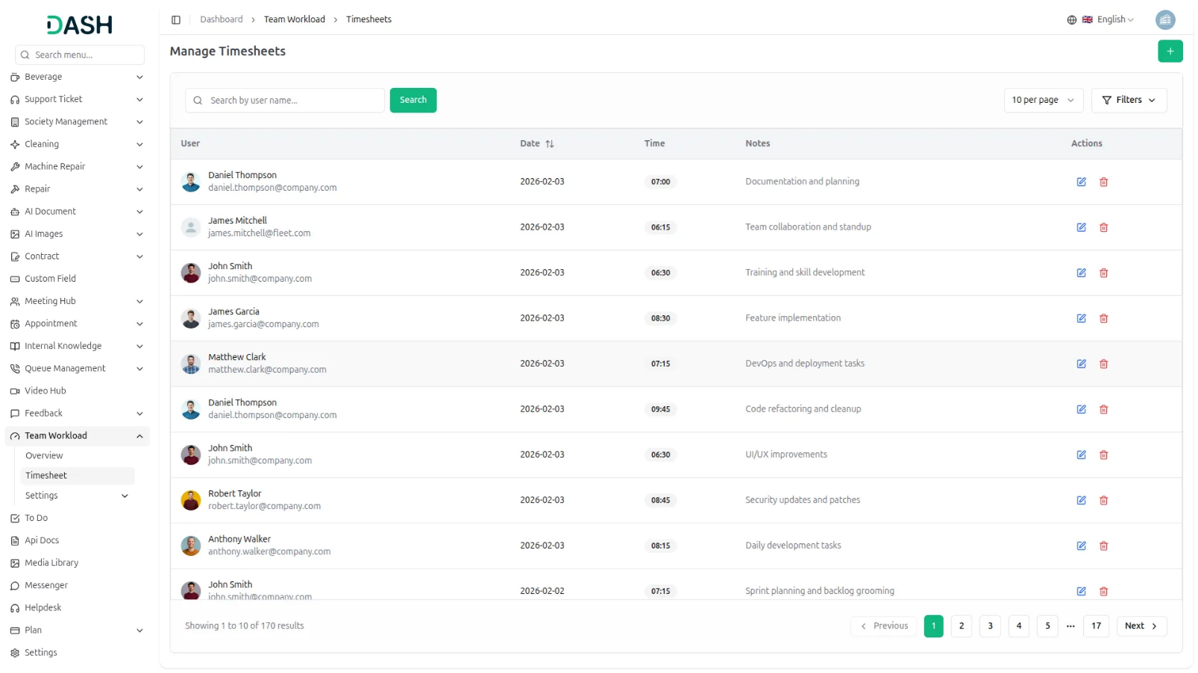

This Team Workload Add-On helps manage employee workloads efficiently within each workspace. Admins can assign individual working capacities, define schedules, and configure holidays to ensure accurate planning. Employees can submit daily timesheets with hours, minutes, and task notes, making it easy to track progress. If an employee logs more time than estimated, the extra hours are automatically highlighted in red. With flexible staff settings and workspace-level control, it supports organized and accountable team operations.

Smart Workload Planning
Easily create and manage each team member’s workload based on their individual capacity. Assign realistic work expectations and plan tasks across working days for better efficiency. Ensure your team is not overloaded and has clarity on their daily responsibilities, with configurations tailored to each workspace and creator.
- Assign individual work capacities with precision
- Define working days for each employee
- Control workloads with creator-based settings
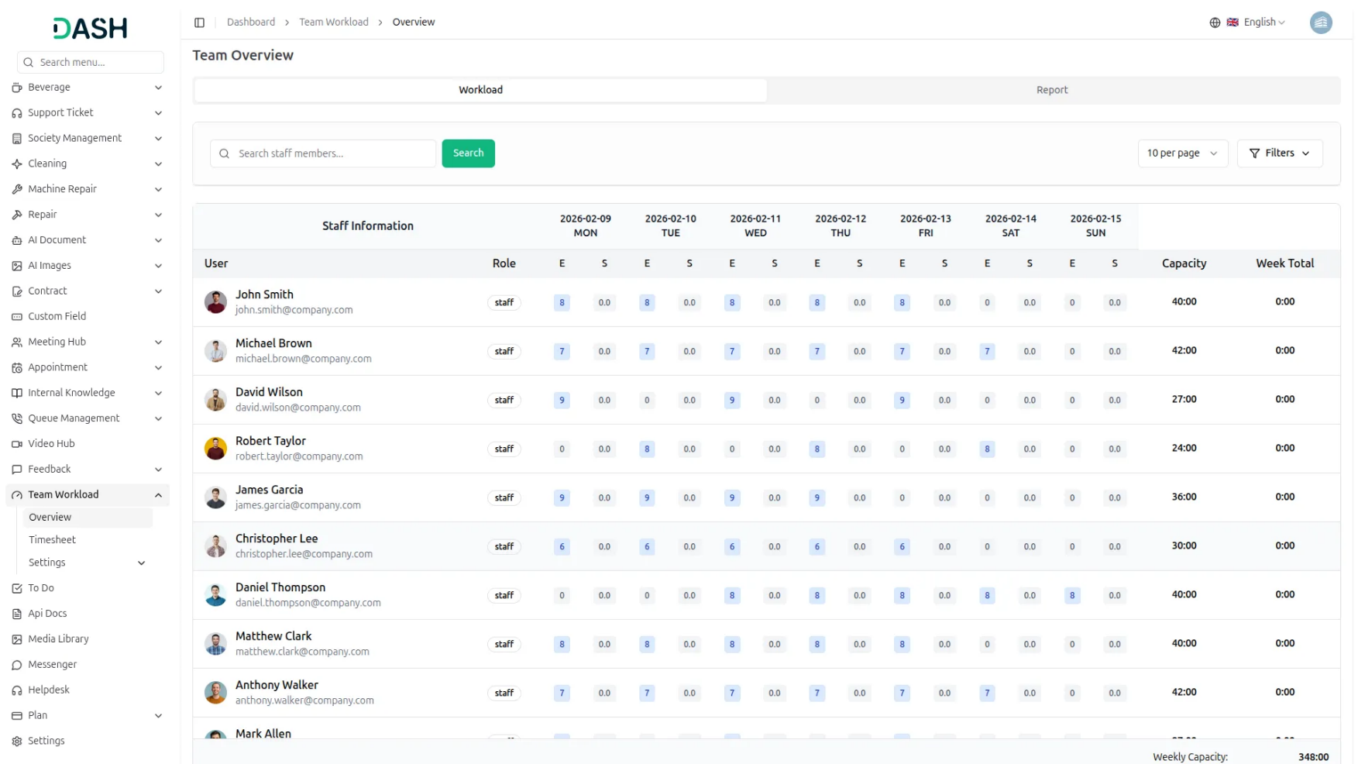
Custom Staff Settings
Set unique working patterns and time capacities for each employee. Enable or disable holiday considerations per staff member, and keep everything aligned with workspace settings. Staff can follow part-time or flexible hours as needed. All configurations are controlled by authorized users for accuracy.
- Set specific daily or weekly hour limits for employees
- Toggle holiday consideration for each staff member
- Customize working days and schedules per individual
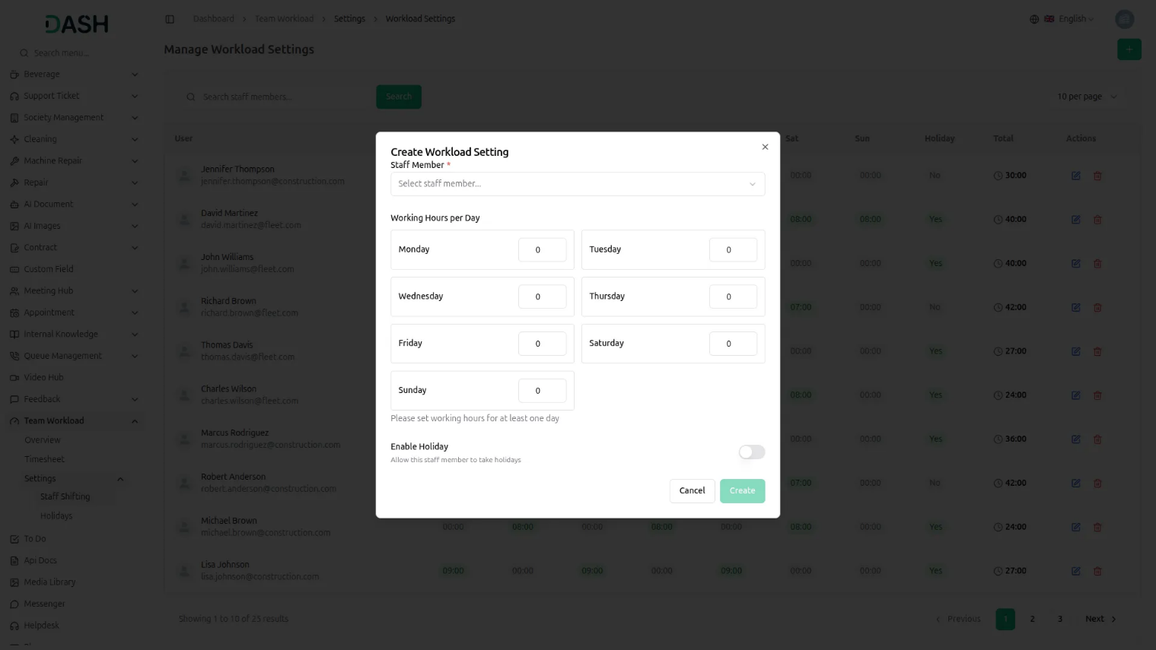
Highlight Excess Work Hours
Easily monitor when employees go beyond their estimated daily work hours. When a team member logs more time than assigned, the system automatically highlights the excess time in red. This visual cue helps managers quickly spot overtime entries and understand workload distribution at a glance. It promotes better time management and helps ensure team members aren’t overworked.
- Automatically highlight extra time entries in red
- Compare estimated hours with actual logged time
- Instantly recognize staff working beyond set limits

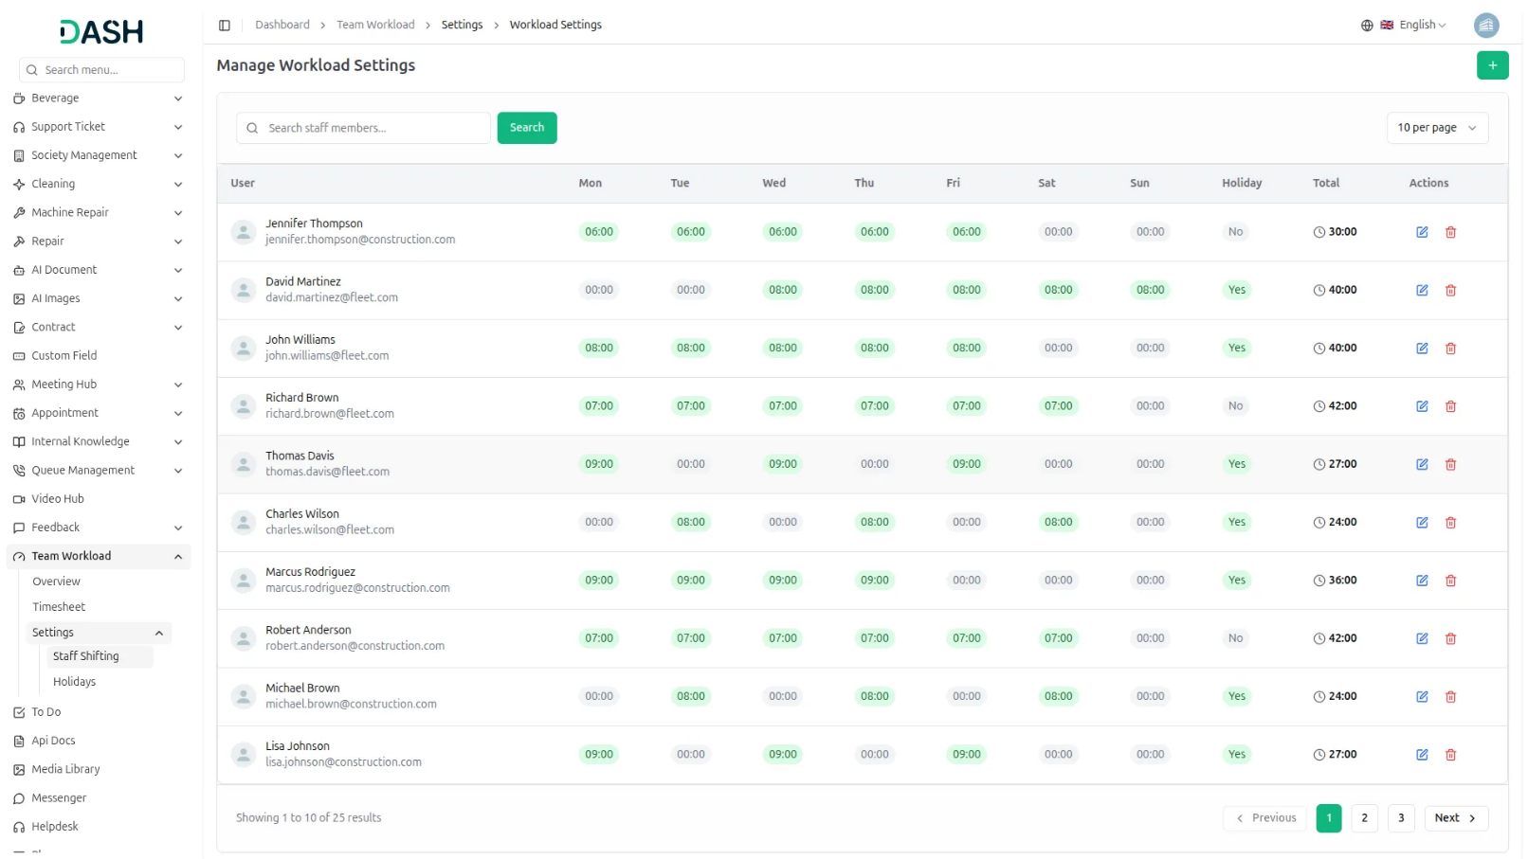
Holiday Management Included
Plan work around holidays by setting start and end dates with descriptions. These entries help to align workload expectations during special occasions or planned leaves while supporting workspace-level separation. Holidays can be added in advance, helping teams prepare ahead of time. Each holiday entry is tied to a specific workspace for better organization.
- Create multi-day holidays with start and end dates
- Add holiday names or occasion details for clarity
- Align employee workloads with scheduled time off

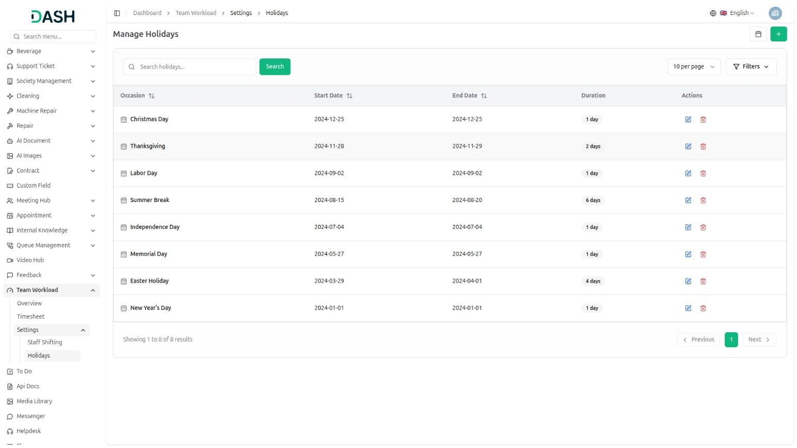

Introduction
The Team Workload Add-On is a highly effective tool for managing employee workloads with ease and efficiency. It tracks and records each employee’s workload information, which can be used to monitor progress and enhance productivity. This Add-On also offers the ability to view graphical representations of workload reports, providing a clearer understanding of overall workload distribution. You can easily add users along with their daily working capacity, and the system will automatically calculate and display their total working hours per week, making weekly workload management simple. Overall, this platform is an excellent solution for managing employee workloads efficiently and effectively.
How To Use The Team Workload Add-On?
Once you purchase and install the Team Workload Add-On, go to the sidebar and search for the Team Workload Add-On. You will get to see many pages over there.

Overview
- So this overview contains two kinds of overviews: workload and report, which are explained below.
Workload
- To create a new timesheet, click on the create button at the top of the page. Enter important details such as selected user, date, hours, minutes, and notes.
- On this page, you will see the list of employees. Having information such as the employee’s name, role, and capacity.
- E stands for Estimated Time, and S stands for Spent Time.
- In the following rows, information about working hours is displayed along with the corresponding day and date.
- If the time spent exceeds the estimated time, it will automatically be highlighted in red. The total of all the information will be given below:
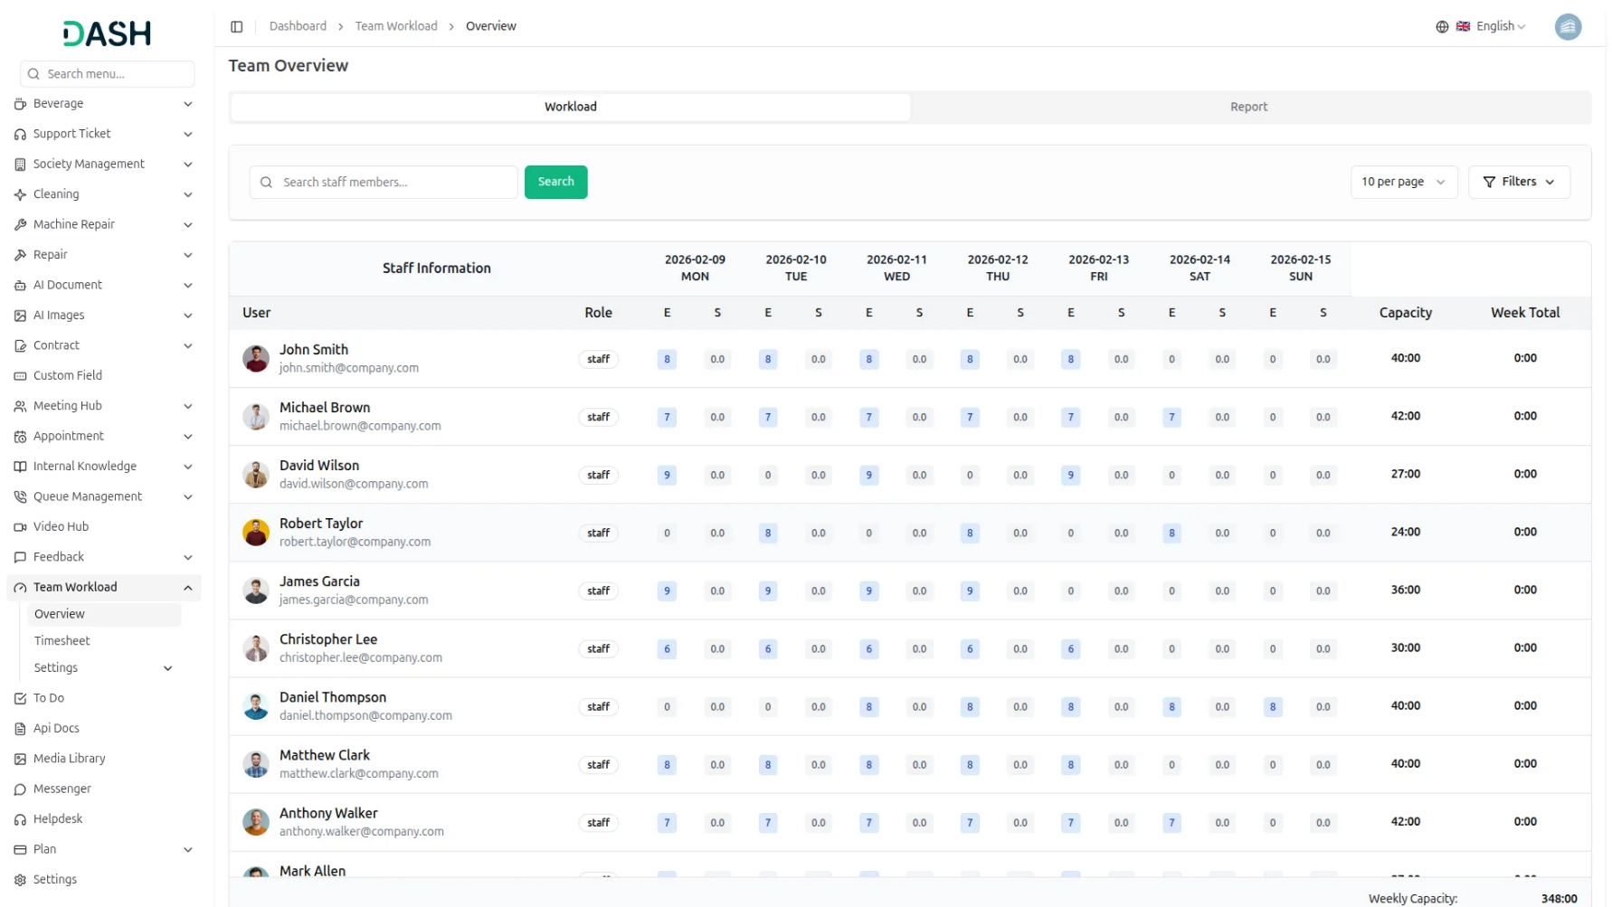

Report
- A graphical overview of staff capacity is provided in this section that displays comprehensive workforce metrics, utilization patterns, and capacity distribution to monitor team performance and optimize resource allocation.
- The donut chart displays information on total capacity, available capacity, and time spent, with visual segments showing the breakdown of capacity allocation and utilization status across the team.
- The line graph illustrates the weekly capacity vs utilization trends for each day throughout the week, showing capacity levels and utilization percentages to identify workload patterns and distribution.
- The bar graph illustrates the total capacity hours for each employee by comparing estimated hours against actual hours worked, providing individual performance metrics for all team members.
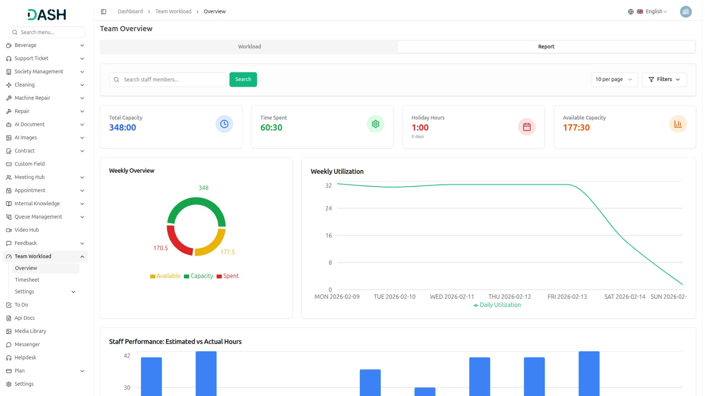
- When filtering by a specific employee in the overview section, the report dynamically updates to display detailed information and performance metrics specific to the selected employee only.
Staff Shifting
- To create staff workload settings, click on the create button at the top of the page to add new staff members and configure their work schedule details.
- Enter important details such as staff member name, working hours for each day of the week, holiday allocation, and total weekly capacity to establish complete scheduling parameters.
- The staff shifting table displays all team members with their daily working hours for each day of the week, holiday status, and total weekly capacity hours for easy visibility and management.
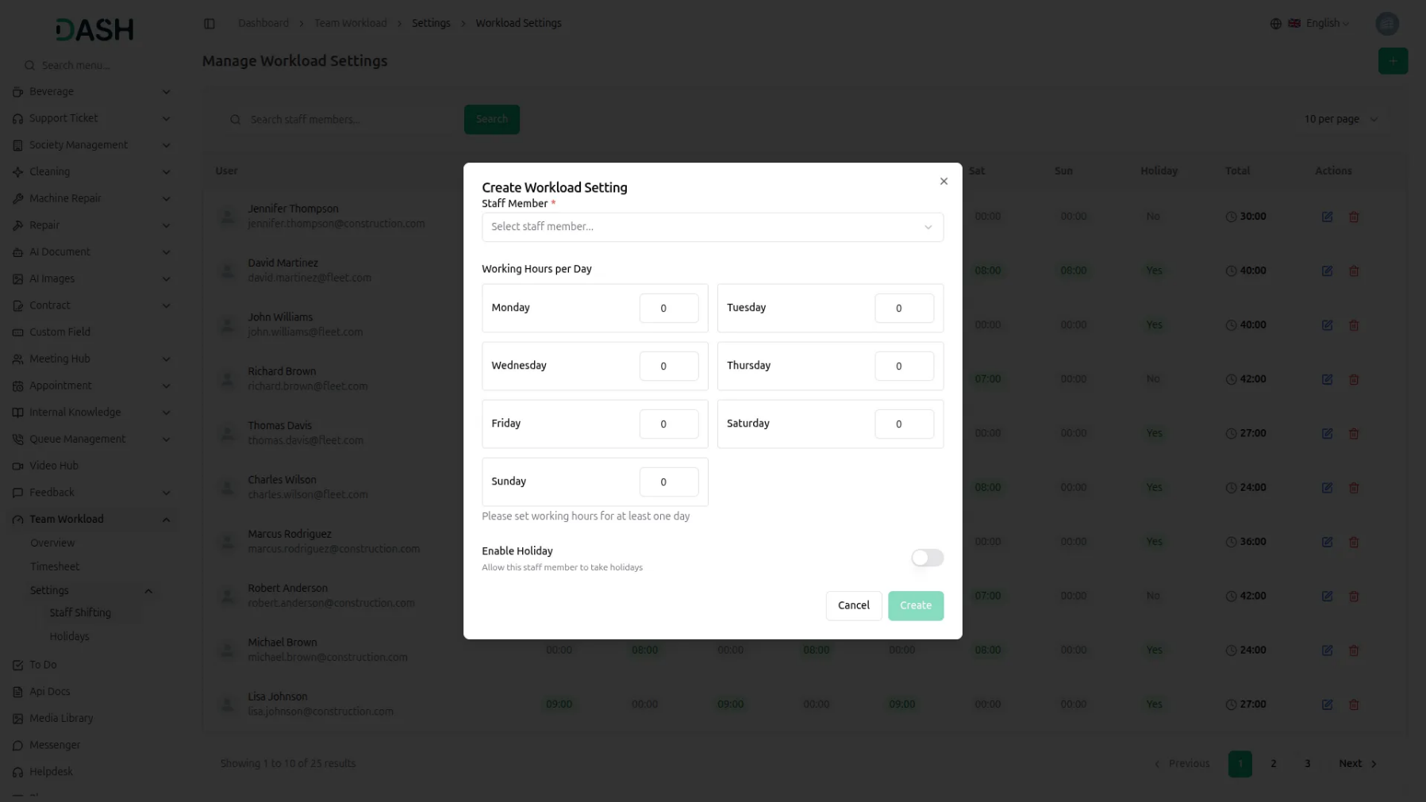
- Each staff member record includes edit and delete action buttons in the Actions column, allowing you to modify staff details or remove staff members from the workload settings as needed.

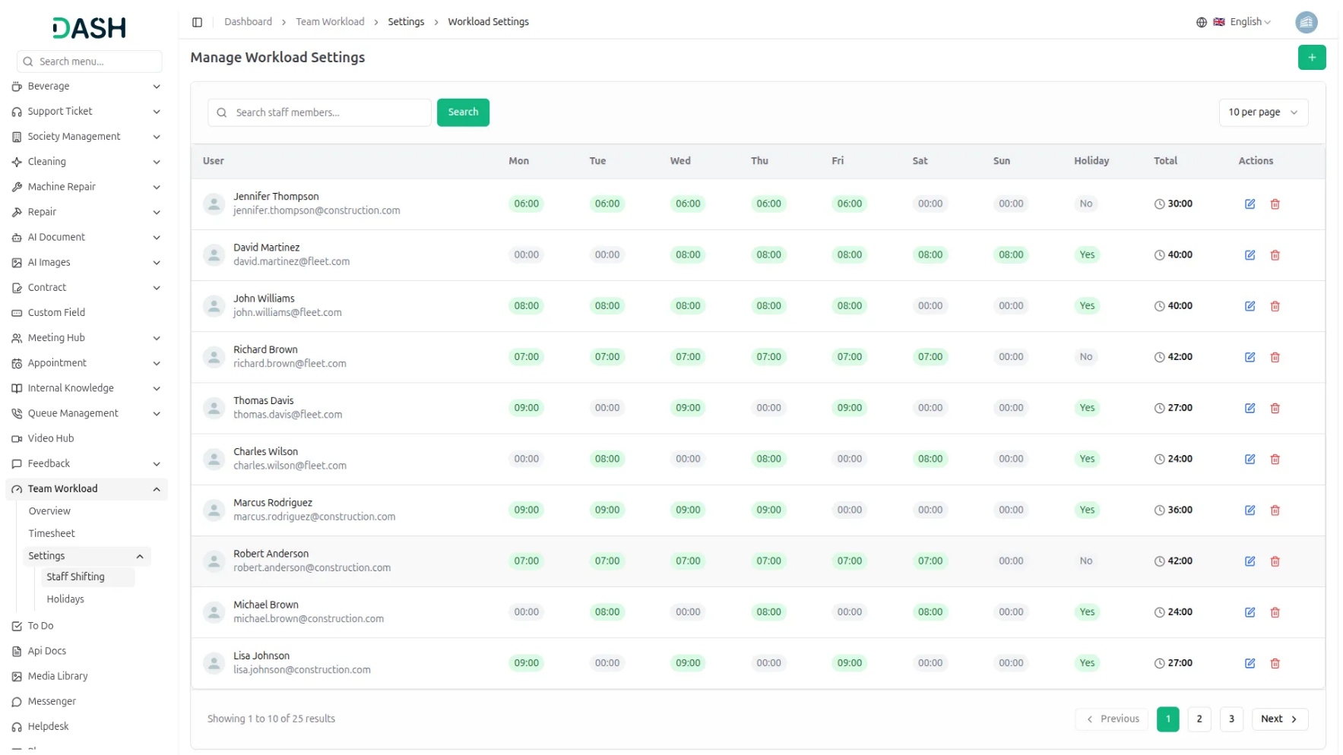
Holidays
- To create holidays, click on the create button at the top of the page. Enter important details such as occasion, start date, and end date.
- You can also filter the holidays, start, and end dates.
- On this page, you can see the list of holidays with the option to edit and delete the list.
- Note: When the HRM module is not active, only you can create Holidays from the Team Workload module; otherwise, you can create Holidays from the HRM module’s HR Admin menu, Holidays
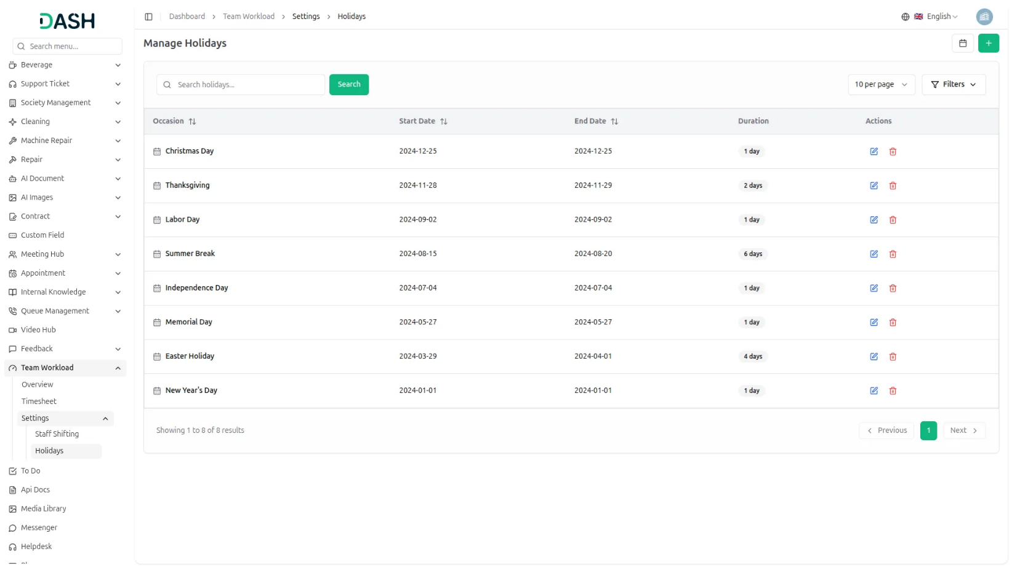

Workload Timesheet
- To create a new timesheet, click on the create button at the top of the page. Enter important details such as users, date, hours, minutes, and notes.
- On this page, you can see the list of timesheets with the option to edit and delete them list.
- The timesheet created by the user by adding the date, hours, and minutes will be considered the timesheet for that particular selected user and day. This will count as the time spent on that particular day.
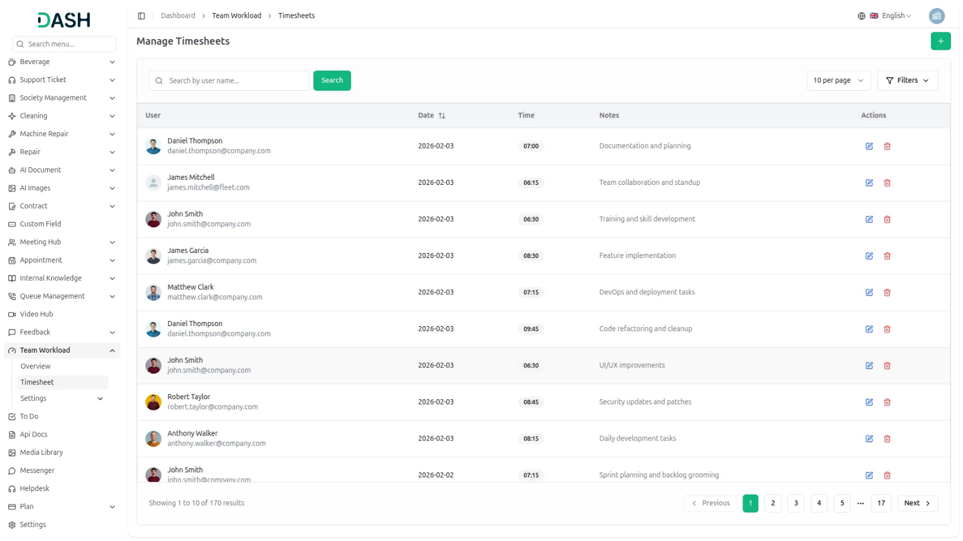
Note: When the Timesheet module is not active, only you can create Workload Timesheet from the Team Workload module; otherwise, you can create Timesheet from the Timesheet module’s menu.

